Rec’d Date:
Rec’d by:
Notified on:
By:

Southern Colorado Interagency
Wildland Fire Team
VOLUNTEER APPLICATION
All applicants are considered for appointment regardless of race, color, religion, sex, national origin, marital or veteran status, or the presence of a non-job-related medical condition or handicap

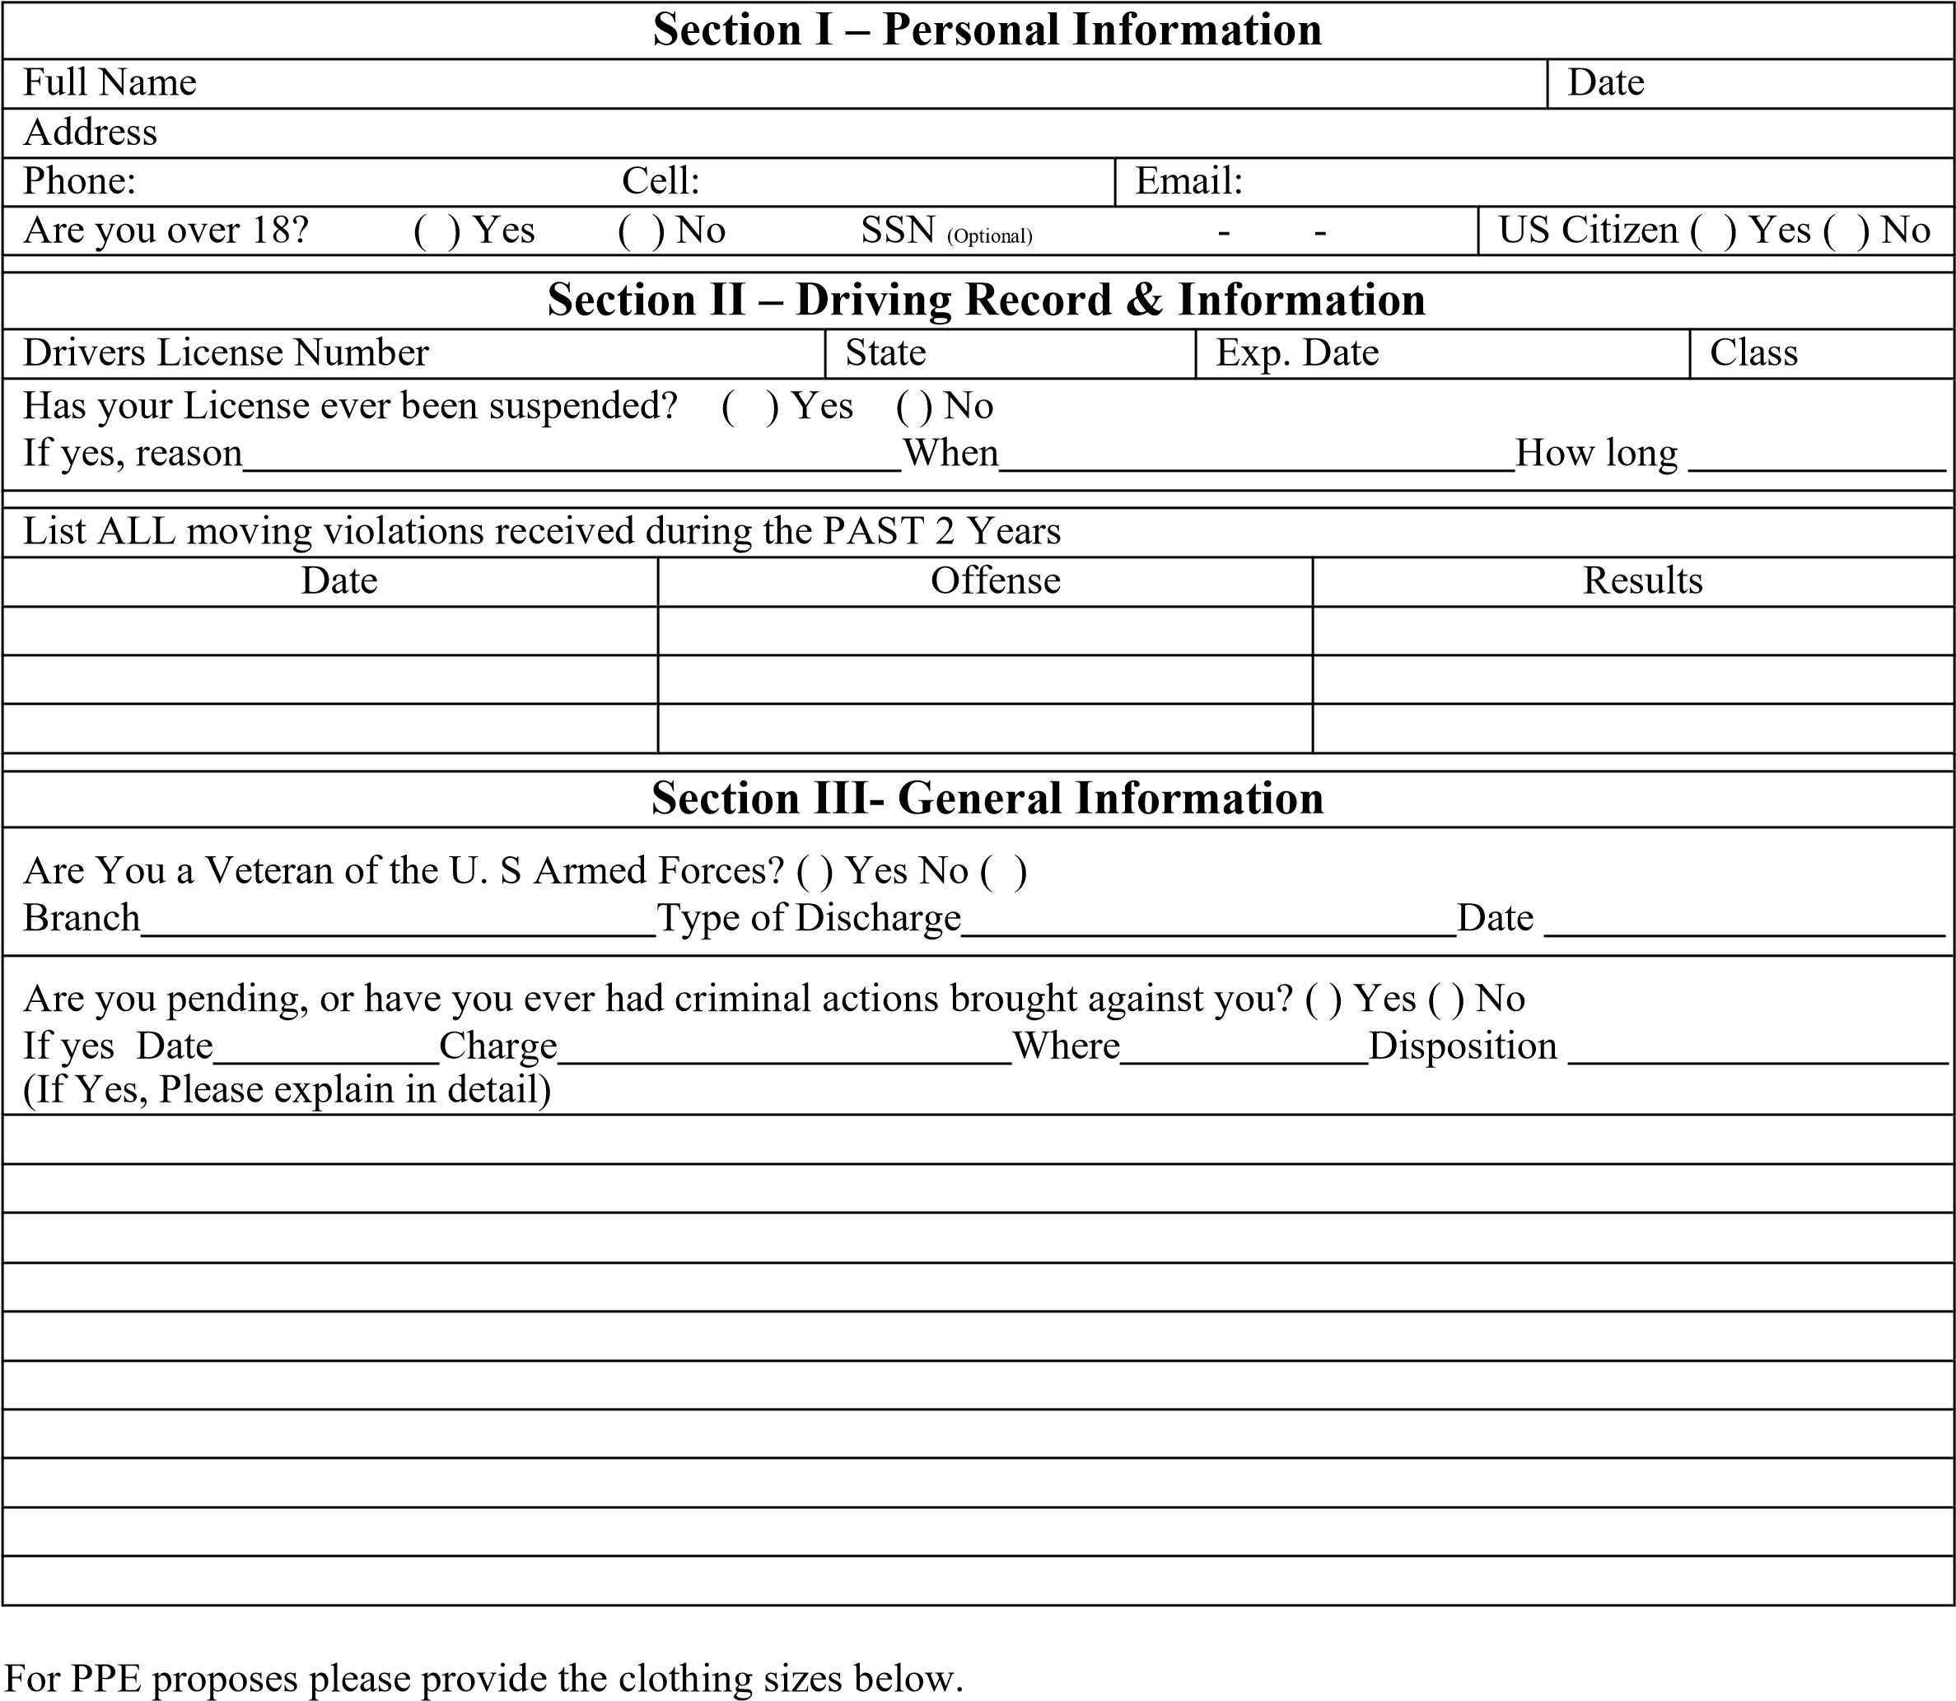

Shirt _______ Pant _______ Hat _______ Torso _______
Section IV - Education
High School Graduate? ( ) Yes ( ) No GED? ( ) Y ( ) N School
College ( ) Yes ( )N Years Major
Vocational / Technical School ( ) Yes ( ) No Course
School
Section V - Related Experience
Do you currently have any certificates, awards, letters of experience in the Fire Service? ( ) Yes ( ) No
(If yes, please list) Field – Date Presented - Presented by – Place - Expiration Date
List any organizations in which you have held membership. (optional)

Section VI - References
List three references
Name | Address | Phone

Emergency Contact |  | Phone:
Name Relation:

Section VII - Employment
Current place of employment: Supervisor:
Address:
Phone Number: Date employed: May we contact this employer ( ) Yes ( ) No
What is your current occupation?

I swear the answers given here are true and complete to the best of my knowledge. I authorize investigation of all statements contained in this application as may be necessary in attaining a decision as to my appointment as a Volunteer with this agency.

I understand that false or misleading information given in my application may result in my not being considered for appointment. I am required to abide by the Policies and Procedures of this Agency.

Applicant’s Signature Date

As part of the application process, you are required to pass the CBI background check. Fill out the attached form and bring it to your scheduled orientation or scheduled interview.

Thank you for your interest in being part of the “SOCO” Team.

IDENTIFICATION UNIT

COLORADO BUREAU OF INVESTIGATION 690 Kipling Street Suite #3000
Denver, CO 80215 www.colorado.gov

PUBLIC REQUEST FOR ARREST INFORMATION

PLEASE TYPE OR PRINT CLEARLY $13.00 Per Name Window Service
Reply will be mailed in 3-5 working days No Personal Checks MON-FRI 8AM – 4:30 PM
IF NOT RECEIVED WITHIN 14 DAYS CALL 303/239-4208

NAME TO BE CHECKED : TYPE OR PRINT LEGIBLY

| / / / / / / / / / / / / / / / / / / / / / / / / | Last Name

| / / / / / / / / / / / / / | | / / / / / / / / / | First Name Middle Name

/ /  MONTH DAY YEAR  DATE OF BIRTH  (REQUIRED) | | M | F |  MALE FEMALE  (CIRCLE ONE) | -  -  SOCIAL SECURITY NUMBER  (OPTIONAL)

SEND REPLY TO: (COMPLETE MAILING ADDRESS)

Hanover Fire Department  NAME OF BUSINESS AND/OR PERSON | .
17550 South Peyton Highway | .
STREET ADDRESS OR P.O. BOX | APT NUMBER
Colorado Springs CO | 80928 - (719) 683-FIRE | .
City STATE  PURPOSE OF REQUEST: (CHECK ONE) | ZIP CODE PHONE NUMBER
BAIL BONDING BAIL BOND LIC# | (MANDATORY FOR BAIL BONDING)
EMT NURSING | PUBLIC X SECURITY GUARD
HOUSING POST BOARD | ADOPTION VISA

ACCOUNT # CONCJ (IF KNOWN)

THE RECORDS REQUESTED SHALL NOT BE USED FOR THE DIRECT SOLICITATION OF BUSINESS OR PECUNIARY GAIN (MONETARY GAIN) : (REQUESTOR SIGN BY THE X PER STATE LAW)

X

CBI ARREST FILE COMPLETENESS: Not all Colorado arrests are documented in CBI files. Colorado Criminal Justice Agencies may not provide all arrests, charges or dispositions to the CBI. Manual reporting (non electronic) Colorado Criminal Justice Agencies has a delay of approximately one to two weeks between the time of arrest and the time CBI receives the arrest card. Sealing is permitted only when the arrestee has petitioned the court for sealing, and has either been acquitted of all charges relating to an arrest, or no charges were filed in the arrest, or all charges were dismissed. The following juvenile records (18 and under) are releasable under the “Open Records Act” misdemeanor traffic, adjudicated as an adult and registered sex offenders.

